

ROLE PROFILE

Service area:  Royal Borough of Windsor and Maidenhead Children’s Services  Management Team | Job title:  Associate Director for Inclusive Education | Post Number: AfC000298

WHO WE ARE

Achieving for Children is an award-winning social enterprise created by Kingston and Richmond Councils in 2014, and responsible for delivering the entirety of both boroughs’ children’s services. In 2017, we expanded across a third local authority area when the Royal Borough of Windsor & Maidenhead joined the company.

Our vision for Achieving for Children is simple: by bringing together professional expertise from three local authority areas, and by putting children and young people at the heart of everything we do, we will be able to deliver improved outcomes for families and give children and young people the best start in life.

ABOUT THIS ROLE

This post reports to the Director of Children’s Services with responsibility for the leadership of all services that support 0-25 education for children of the Royal Borough of Windsor and Maidenhead. This includes strategic work with school and college leaders to shape provision and processes so that all children and young people attend appropriate local education and achieve well. There is a particular priority to ensure that those with additional needs or living with disadvantage succeed.

As a key member of the Windsor and Maidenhead Children’s Services management team this post is also responsible for collaborating to drive an inclusive culture which seeks to improve the life chances for all children across all services within AfC and the local authority.

Achieving for Children continually reviews its structure and business practices in order to provide the best possible services for children, young people and their families, in the most effective and efficient way. As a result, the key tasks in any job profile may be varied.

RELATIONSHIPS

Responsible to: Director of Children’s Services

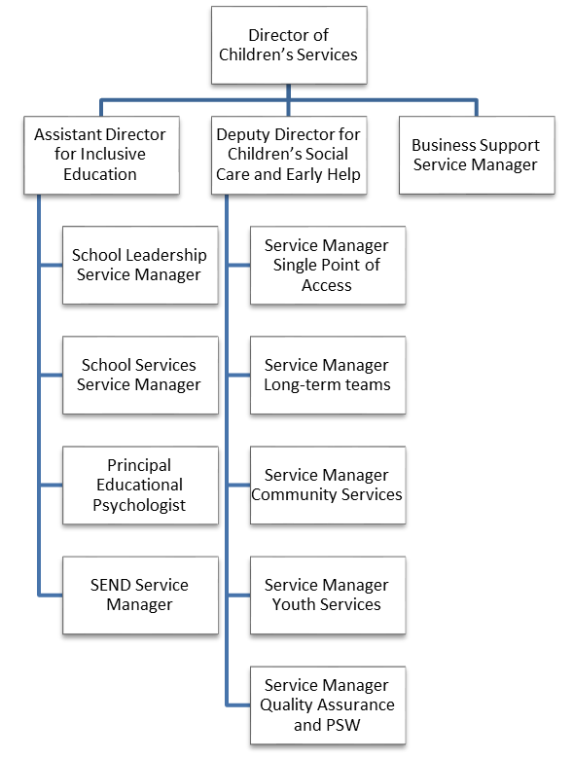
Important internal relationships:
- Director of Children’s Social Care and Early Help.
- RBWM Children’s Commissioner.
- The lead member for Children’s Services
- Head teachers and Governors of maintained schools

Important external relationships:
- Leaders of all nurseries, schools and colleges within the local authority area
- The Chair of the local Schools Forum.
- Ofsted regional officers for education and early years support.
- The Designated Clinical Officer in the CCG for effective SEND provision
- The Chair of the local Parent Carer Forum
- SEND and Education representatives within national government and the regional improvement alliances

MAIN PURPOSE OF JOB

To lead and manage the diverse range of services provided to schools and education providers, by either statute or through traded services, so that young people thrive into adulthood, while managing the overall Dedicated Schools Grant.
These services include school place planning and commissioning; school admissions; school improvement; school governance; SEND leadership; EHCP management; early years education; high needs block commissioning; educational psychology and support to early years settings.

MAIN RESPONSIBILITIES/DUTIES OF JOB

- Provide leadership to the Inclusive Education management team to ensure that services work together to ensure ALL young people are able to access high quality, local provision whenever possible.

- Implement a robust system for monitoring the quality and impact of work, driving service improvements as required to drive forward effective services across the portfolio, funded in the main by the £119m annual Dedicated Schools Grant.

- Lead commissioning and planning activity for mainstream school places, SEND provision and support services to drive reliable quality education with good value for money.

- Provide strategic advice to, and oversee the effective operation of, the local Schools Forum including the ongoing work to contain the High Needs block pressures.

- Support school leadership services to continue to develop the proportion of good and outstanding schools through effective commissioning of school to school support and statutory services. Maintain the supply of new teachers through the local authority’s initial teacher training offer

- Drive the multi-agency arrangements for services for children with additional needs to increase the inclusion rates of local schools while increasing the effectiveness of the processes so more young people are satisfied with the service.

- Oversee the operation of local authority services including Admissions and Home to School transport to ensure compliance with the appropriate regulations while driving innovation and policy to manage the growing demands on the services

- Promoting high standards of practice in safeguarding having particular regard to statutory guidance on safeguarding across education. Follow agreed policies and procedures when there are concerns that need to be acted upon.

- Contribute to the broader aims of the Directorate using highly refined communication skills inform wider stakeholders of the remit and functions of the wider service.

- Undertake any other duties commensurate with the grade of the post, as may be required from time to time.
PERSON SPECIFICATION
Children’s Services
Job title: Associate Director for Inclusive Education

Qualifications
Educated to degree level, with appropriate professional qualification/s. | Essential
Knowledge
Extensive experience of leadership in mainstream school environments with an understanding of the regulatory and inspection frameworks which apply in the sector. | Essential
Knowledge and understanding of legislation, statutory frameworks and policy affecting services for children, young people and families in relation to SEND. | Essential
Experience of coproduction and effective commissioning of services with a wide range of partners, along with the appropriate governance. | Essential
Skills, experience and personal characteristics
Experience of building and maintaining successful relationships with a range of influencers, including school leaders, councillors and commercial providers. | Essential
Proven ability to network, build relationships and influence others. | Essential
Proven ability to manage and control large revenue and capital budgets through delegated management functions to deliver accurate forecasting and innovative transformation | Essential
Ability to work as part of an effective and supportive team, including those from other organisations. | Essential
Active commitment to a culture of innovation, including a willingness to challenge traditional ways of working. | Essential
The ability to meet deadlines and adhere to the agreed timelines and prioritise workload as required | Essential
A high level of determination, personal drive, energy and ambition to achieve challenging targets and improve outcomes. | Essential
Commitment to an organisational culture and the development of services that value equality and diversity. | Essential

