

ROLE PROFILE

Service area:  Children and Young People Disability Service | Job title:  SEND Service Manager | Post Number: AfC000297

WHO WE ARE

Achieving for Children is an award-winning social enterprise created by Kingston and Richmond Councils in 2014, and responsible for delivering the entirety of both boroughs’ children’s services. In 2017, we expanded across a third local authority area when the Royal Borough of Windsor & Maidenhead joined the company.

Our vision for Achieving for Children is simple: by putting children and young people at the heart of everything we do, we will be able to deliver improved outcomes for families and give children and young people the best start in life.

Focussed on the children and young people who live in the Royal Borough of Windsor and Maidenhead, this post is part of the leadership of the Inclusive Education service and plays a key role in the virtual Children and Young People Disability Service (CYPDS) based in Maidenhead.

The CYPDS service is a multi-professional service and includes special educational needs, social care, occupational therapy, family work and a wide range of support functions such as the Local Offer and Short Breaks. We work with children and young people aged 0 -25 years and aim to help those families navigate a range of services.

The Inclusive Education service is a new team which has been brought together to strengthen the services which help schools increase inclusion while maintaining the strong ethos of attainment within the borough.

RELATIONSHIPS

Responsible to: Assistant Director for Inclusive Education

Important internal relationships:
- Colleagues in the CYPDS management team.
- Colleagues in social care and education teams.
- Home to School transport and finance colleagues.
- Internal complaints and compliments team.
- Information, Advice and Support Service (IAS).

Important external relationships:
- Families and Children and Young People with additional needs.
- Parent and Carers in Partnership (PaCiP) parent’s representative forum.
- Nurseries, schools and colleges teams dealing with all aspects of the EHCP processes.
- Health and social care managers responsible for ensuring their services contribute to EHCP plans and processes.
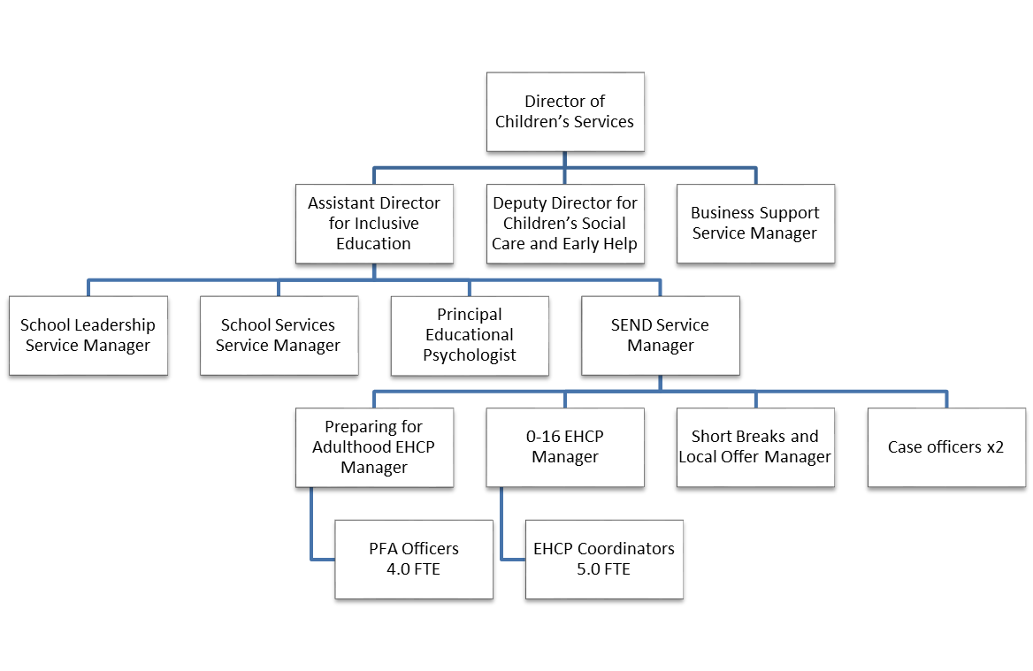

MAIN PURPOSE OF JOB

To lead and develop the SEND service to deliver all statutory responsibilities for Special Educational Needs/Disabilities (SEND) aged 0-25 years including the assessments for Education, Health and Care Plans, provision and funding, maintenance of existing plans and the Preparing for Adulthood model.
Management responsibility for five key posts within CYPDS.

MAIN RESPONSIBILITIES/DUTIES OF JOB

- As the lead professional for Education, Health and Care plans, develop and manage the service in line with statutory and local requirements.

- Manage all statutory responsibilities for young people with an Education, Health and Care Plan (EHC) aged 0-25 years including that EHC plans for this group are legally compliant with the statutory requirements of the Children and Families Act 2014.

- Ensure the annual £11million top –up placement budget is transparently and accurately managed.

- Make placement decisions on behalf of the LA, ensuring decisions are cost effective and in line with policy and statutory requirements.

- Act as designated local authority signatory for EHC plans along with other relevant colleagues/partners on behalf of the Director of Children’s Services.

- Ensure appropriate processes are in place to manage all aspects of the SEND panels.. This includes requests for assessment, provision of new plans and placements. Ensure an effective quality assurance process, including with partners, results in improved satisfaction of parents and young people.

- Implement a robust system of monitoring the quality and impact of the annual review process, which relies on partners to drive the volume of work.

- Overall responsibility for SEND mediation cases and lead and manage the preparation of the Local Authority’s response to formal tribunal cases in partnership with our legal service. This will include representing the LA at hearings..

- Lead on the engagement processes with health and schools to resolve those challenging issues that are impacting on the progression of cases/decision making.

- Use appropriate management information to inform the development of the service to improve operational effectiveness and influence future provision planning.

- Manage all contracts and operating arrangements for a range of educational providers, including monitoring take up and funding accuracy.

- Promoting high standards of practice in safeguarding having particular regard to statutory guidance on safeguarding disabled children. Follow agreed policies and procedures when there are concerns that need to be acted upon.

- Undertake relevant training and professional development to ensure knowledge, skills and understanding of matters relating to special educational needs/disability, inclusion and professional practice remains up to date.

- Contribute to the broader aims of the Inclusive Education and CYPDS services to improve integrated delivery to children and young people with SEND and using highly refined communication skills inform wider stakeholders of the remit and functions of the service.

- Undertake any other duties commensurate with the grade of the post, as may be required from time to time.
PERSON SPECIFICATION
Children’s Services
Job title: SEND Service Manager

Qualifications
Educated to degree level, with appropriate professional qualification/s. | Essential
Knowledge
Knowledge and understanding of legislation, statutory frameworks and policy affecting services for children, young people and families in relation to SEND. | Essential
Extensive experience of operating a system to assess, plan, issue and review EHCP’s in collaboration with schools, health and social care providers | Essential
Extensive experience of working with children and young people with SEND and their families coupled with a good understand of needs. | Essential
Skills, experience and personal characteristics
Experience of building and maintaining successful relationships with a range of influencers, including schools. | Essential
A good knowledge of safeguarding legislation related to disabled children, young people and their families. | Essential
Proven ability to network, build relationships and influence others. | Essential
Ability to work as part of an effective and supportive team. | Essential
Active commitment to a culture of innovation, including a willingness to challenge traditional ways of working. | Essential
The ability to meet deadlines and adhere to the agreed timelines and prioritise workload as required | Essential
A high level of determination, personal drive, energy and ambition to achieve challenging targets and improve outcomes. | Essential
Commitment to an organisational culture and the development of services that value equality and diversity. | Essential

